B. In-Depth Explanation & Analysis
1. The Service Sector Ladder (Tertiary to Quinary) Think of a hospital.
- Tertiary: The receptionist booking your appointment, the ambulance driver. (Basic services).
- Quaternary: The lab technician analyzing your blood sample, the specialist doctor diagnosing a rare disease. (Knowledge-based).
- Quinary: The Hospital CEO deciding to build a new cancer wing, or the Health Minister making new healthcare laws. (Top-level decisions).
2. Transport Modes: Choosing the Right One
- Road: Door-to-door service, best for short distances and small loads. Flexible.
- Rail: Best for bulky goods (coal, grain) over long distances on land.
- Water: Cheapest for massive cargo between continents (oil tankers, container ships), but very slow.
- Air: Fastest for high-value, light, or perishable goods (diamonds, flowers, emergency medicine), but most expensive.
- Pipeline: Best for liquids/gases (oil, water, natural gas). Continuous flow, low running cost once built.
3. Balance of Trade vs. Balance of Payment
- Balance of Trade (BoT): Just goods. (Value of Exports - Value of Imports).
- Balance of Payment (BoP): Wider concept. Includes goods AND services (like tourism money, software exports, remittances from NRIs).
- The "Digital Divide" While the internet connects the world, not everyone is connected equally. Developed countries have fast, affordable access. Developing countries often have slow, expensive, or no access in rural areas. This gap in information access is the Digital Divide.

Mentor’s insight:
- Types of trading: retail trading (consumer cooperatives, departmental stores and chain stores, street peddling, door-to-door etc. are examples of retail trading) and wholesale trading (bulk business, here goods are often bought directly from the manufacturer).
- Types of distance measured in transport are: km distance, time distance and cost distance.
- Remembering which job falls under what category is important for example CEO of a an MNC falls under quaternary activities.
- You can mention local examples while writing answers like the dabbawala service in Mumbai.
- First public railway line was opened between Stockton and Darlington in northern England in 1825.
- Europe has the highest density of railway network in the world, in which Belgium has the highest density of 1km railway for every 6.5 sq kms area.
- Important railway lines to remember are Channel tunnel (connects London with Paris), Trans-Siberian railway (runs between St. Petersburg in the west and Vladivostok on the Pacific coast), Trans-Canadian railway (between Halifax in the east and Vancouver on the pacific coast) 7,050 km long, Union Pacific railway (New York to San Francisco), Australian Trans-Continental railway (Perth to Sydney), the Orient Express (from Paris to Istanbul).

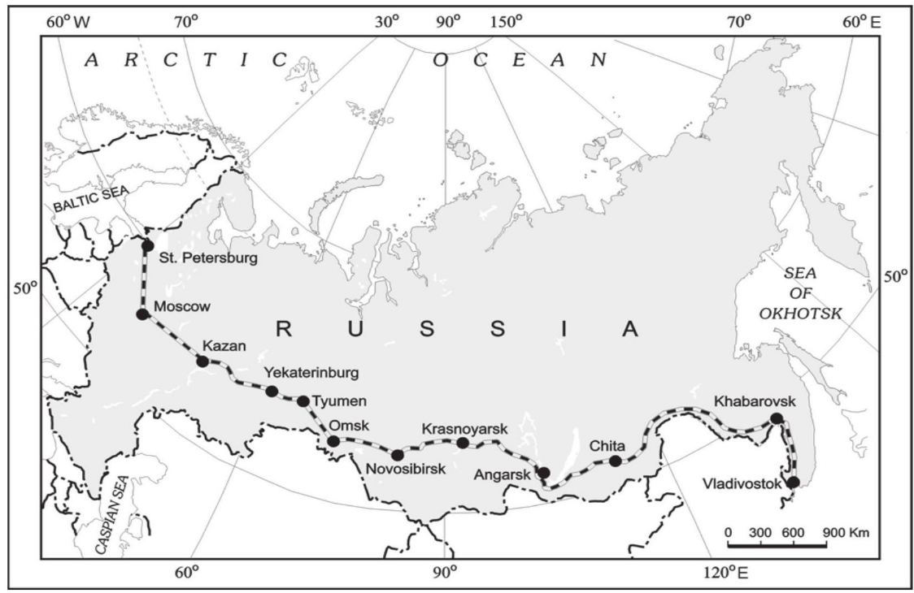
Trans-Siberian Railway

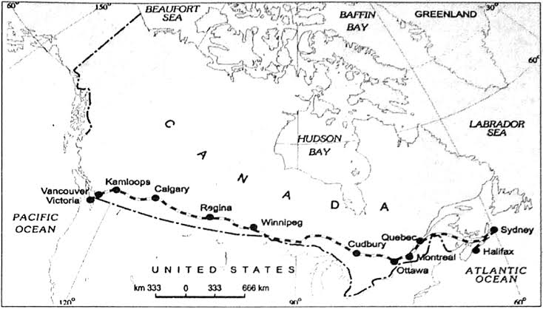
Trans-Canadian railway
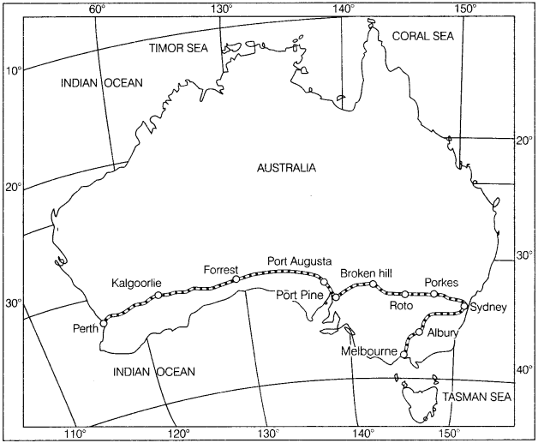
Trans-Australian Railway
- Remember the major highways for example The Pan American highway, the Trans Continental Stuart highway (Australia), The Golden Quadrilateral Highway (India) connecting the four metropolitan cities – New Delhi, Mumbai, Chennai and Kolkata.
- Important sea routs to remember are The Northern Atlantic Sea Route, The Cape of Good Hope Sea Route, The Mediterranean-Indian Ocean Sea Route etc.

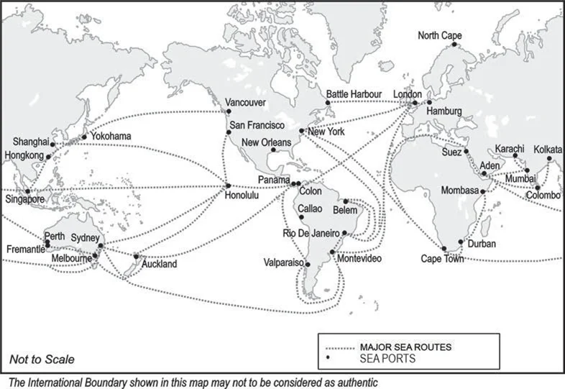
Major Sea Routes and Sea ports
- The Suez Canal and Panama Canal are very important and are often asked in a comparison question, to secure full marks draw a comparison table.
- Important inland waterways are The Rhine waterway, The Volga waterway, The Great lakes – St. Lawrence seaway, The Danube Waterway and The Mississippi Waterways.
- Pipelines are used to transports liquid and gases like cooking gas, milk in New Zealand.
- Jon Bheel mela, barter system. Silk Route connecting Rome to China a 6,000 km route.
- Slave trade was abolished in Denmark in 1792, in Britain in 1807 and in the United States in 1808.
- Basis of international trade are often asked so make sure to read that thoroughly.
- Ports are called the Gateways of International Trade. Remember the types of ports on basis of location, function and cargo handle

